(Approx. 1,686 words)

Shrinking Computing
Intel Plays In All the Fields But…Size Matters!
By Andy Marken, President, Marken Communications
www.marken.com
andy (at) marken.com

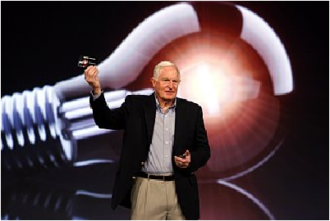
Bright Idea – Just so no one missed the fact that Intel’s Craig Barrett was talking about another bright idea that the company’s engineering teams had developed the events folks put him in front of a light bulb. It didn’t work because we could barely see the itty-bitty device he held in his hand at the opening of IDF this year. Source -- Intel

“Well, that's right, Professor Frederickson, and that all matter is made up of not only density but of empty space, and if we can proportionally reduce the amount of empty space in any given object, we can, thereby, shrink the object.” – Wayne Szalinski (Rick Moranis), Honey I Shrunk the Kids (1989)

We always enjoy the Intel Developers Forum (IDF) because 98 percent of the time the demos work.

When they don’t work, you’re pretty sure no one will get sent to the Bering Seas to work on The Deadliest Catch series.

No sweat this year! Craig Barrett, Intel’s chairman, wanted everyone to know that the company was just flush with fresh ideas (see photo) so he waved around and talked about an itty-bitty something you couldn’t really see.

Heck could have been one of his new fishing lures…who’d know?

Of course Paul Otellini, Intel Prez, had to show off their huge silicon platters with a gazillion chips on it.

To hear him talk you’d think that everything we use everyday would be useless without his chips. Look around…he may be right.

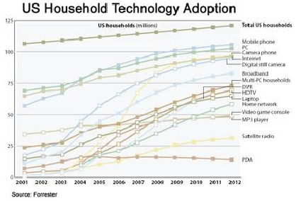

Figure 1 - Laden With Technology – Life would really be great if you only had to have one work/communications/entertainment device as all of the manufacturers would have you believe. Problem is people seem to want different things for different activities. So our collection continues to grow…and grow. Source -- Forrester

For him it was all about performance, raw speed.



Figure 2 - Speed Trials – With every speed and performance advance, consumers raise their expectations for speed and performance. It never seems to be powerful enough or fast enough. Good thing because that only fires the demand for newer and better devices for work and play. Source -- Intel

Obviously if you need an excuse to upgrade your devices every six months it is all about speed, performance!

Glad the wife wasn’t there. She would have been so ticked about her new, barely used, now outdated Dell notebook.

Notebooks Still Cool

What’s not to like about a good notebook computer?

You can do everything with the sucker!
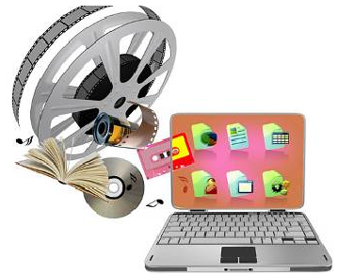

Figure 3 - Content Buckets – People like today’s notebook computers because they are relatively light and deliver versatile storage and playback – photos, videos, music and even work. They also aid people in staying connected around the globe. Source – NY Times

Photos…music…video…search…work…study…stay in touch.

It’s no wonder notebook sales have equaled and surpassed desktop sales. The numbers just keep growing.

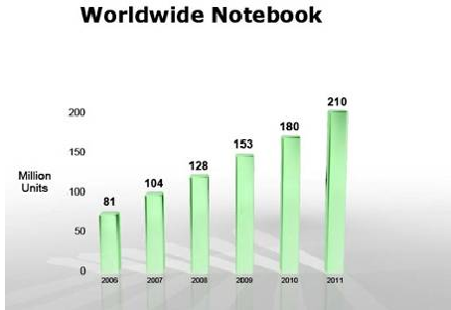

Figure 4 - Growth Path – Notebook computer sales show steady potential as they become lighter, more powerful and more reliable. Users can stay in touch, enjoy hours of music/video entertainment and carry filing cabinets of work with them in a unit that usually weighs less than five pounds. Notebook sales today surpass desktop sales. Source – IDC

They’re so popular, so versatile that we have two categories…those you work with and those you slip into an envelope.

Where’s the machismo with the light systems from Apple, Lenovo and others? Used to be a badge of honor to have you knuckles drag on the floor from carrying your luggable computer. Sheess now first graders stuff the units in their backpacks and take them to school. The power systems are “pretty” light…ok pretty! The envelope systems are downright ridiculous. People keep trying to make them lighter but there is only so much you can do… Add all the parts together and you’ve got a weight “problem”.

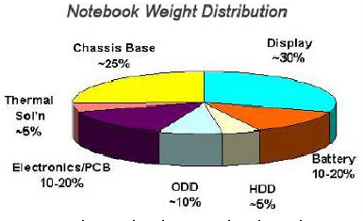
Figure 5 - Fixed Numbers – While component and system engineers work creatively to drive cost and weight out of computers while increasing performance and capabilities, the laws of diminishing returns also comes into play. As you add features and applications they add to the weight of the system. The laws of physics still apply. Source -- Intel

Since they can’t change the laws of physics they figured they’d simply make you change the way you think about and use computers.

One of the first out of the chute (right after OLPC) was Asus with their eee – dumb name, pretty good idea.

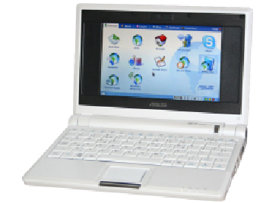

Figure 6 - Cloud Computing – If you want to drive a lot of weight, power consumption and cost out of your portable computer look closely at the new netbooks. The systems are light, decently powered, have good data life, respectable battery life, some storage capacity. It’s all good if you can connect to the Internet. Source -- Asus

Oh sure it was light weight, used socialist (Linux)-based operating system, (small) solid state drive and was relatively cheap. Barrett convinced them of the errors of their ways though and brought Asus out into a Windows/hard drive world. True, that raised the price a little.

But folks come on??? We’re talking Windows! We’re talking HDs !!
As Wayne Szalinski said…“I think that went well.”

Teens and Tweens like the idea of a netbook and operating in the cloud. But then…they didn’t know life BI (Before Internet). Netbook prophets say it’s going to be a huge market WW. So big that every manufacturer on the planet is bringing out their small, cheap netbook…and cheaper…and cheaper and…Otellini loves it…more chip sales!

Asus wants to keep ahead of the game so they have started offering their flavor of storage in the cloud. Then they added fashion systems that smell (ok they call them fragrances but really…). At the really low end of the shrink-your-tools spectrum lots of us learned to tolerate the Blackberry. Not a half bad phone…good for email…lousy for typing. Everyone mimicked them, largely to no success.

Thanks Steve

Then Jobs had to come along and muck up the waters. Ok so the phone part of his iPhone sucked but sheess…gotta admit it is cute.

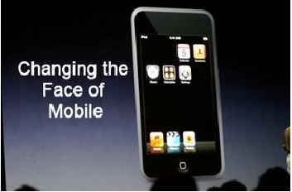
Figure 7 - Neighborhood Watch – Steve announced his new approach to phones and the world hasn’t turned back. The clean, crisp design and ability to do everything (ok not a great phone call but…) with a single device got engineers around the globe rushing back to their labs to reverse engineer their version. Source -- Apple

You now surf the web…watch your videos…look at your photos…play your iTunes…email…shave…cook eggs…all the really important stuff! And people quickly glommed onto the new mobile activities.

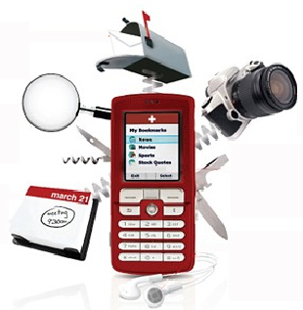

Figure 8 - Smart Sweep – If you’re a teen or tween the idea of using a smartphone as your all encompassing communications/entertainment device is a logical next move. The better units let you call, text, im, take photos, listen to music, shoot videos, email, clean your fingernails (ok maybe not right now but …). Service providers like the new everything devices because it means more data service program sales. Source -- IDC

It no surprise that a recent Simmons New Media study found that there are more mobile phones in use than cars (800M) or computers (1.2B).

But what they’re doing shows people need to be constantly connected:

59% text messaging
49% taking photos
20% emailing
19% accessing the Internet
13% taking videos
6% banking
5% accessing GPS positions
2% shopping

If you listen to Jobs, the mobile everything sellers and the Kool-Aid drinking forecasters you’re probably asking the same question Professor Frederickson asked… “Mr. Szalinski, are you trying to tell me that suddenly size is no longer relative?”

Oh they’re good, they’re fun, they’re useful. The pocket-sized, thumb-dislocating multimedia devices show plenty of growth potential.

Mobile Growth

In fact, the entire mobile device market continues to show promise. But profit margins are grim …except for Steve

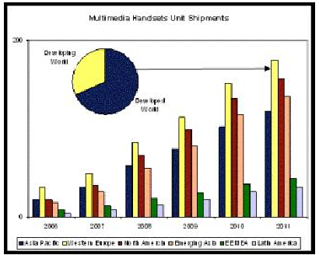

Figure 9 - World Divided – Mobile device manufacturers have a phone for every segment of the market. Highly industrialized countries are ready markets for iPhones/smartphones. People in developing countries will want feature phones. Users in third-world countries want food, work, an occasional phone call. Source -- iSuppli

The iPhone and “enhanced” versions will do well in today’s mature markets (Canada, US, Korea, Japan, Australia, most of the EU). Money may be tight but folks justify the coolness factor. Emerging countries (Brazil, Mexico, India, China, Russia, etc.)?

Somewhat.

The ROW?

They’d be happy to make a call, let alone worry about emailing or online banking!

Barrett and Otellini aren’t concerned about one device (design win) replacing another.
Petaluma (CA) is not going to replace their World Armwrestling Contest for thumb wrestling.

Our kids schlep their notebooks with them. They have their iPhone look-alikes. They have their iPods. Son has his netbook and PSP. Daughter has her camera. We’ve got their battery chargers! Pile ‘em On

People don’t suddenly discard one communications/entertainment device for another.
They add to their arsenal of work/play toys.

Sure it would be cool if you could shrink and unshrink them in the blink of an eye because then as Wayne emphasized, “And given that my machine can substantially reduce the size of bulky payloads.”

That isn’t possible…yet. So we buy pants with bigger pockets…bigger purses…stronger backpacks.

We’re certain that Otellini’s team (in some deep, dark lab) is working on a computer on a chip that can be implanted because let’s face it, that’s a six billion market that overshadows PCs and phones!


Figure 10 - My New Phone – With the industry’s growing ability to shrink circuitry and technology it may not be long before your cellphone and perhaps even your everything phone can be so small you’ll have to use a magnifying glass to watch your shows, make your calls. Of course kids (little kids) will learn how to adapt while adults struggle. Source – Walt Disney Pictures

Of course if its Windows based you’ll probably crash periodically or need to reboot. Remember those problems never happen with Macs or Linux systems. And of course no one sends those folks viruses or Trojan horses or hacks ‘em!

Just remember…drinking Kool-Aid and driving don’t mix!!!!

